Detailed Example For Importing Permits Files to Microsoft Excel:

Save the Building Permits files to either your desktop or your hard drive

Run Excel

Click File - Open

Under "Look in" go to the area where the Building Permits files were saved:

In this example the files are saved under:

M:\ADC Construction Indicator Programs\RCB\BPERMITS\FILES\RES\PLACE\UNCOMPRS

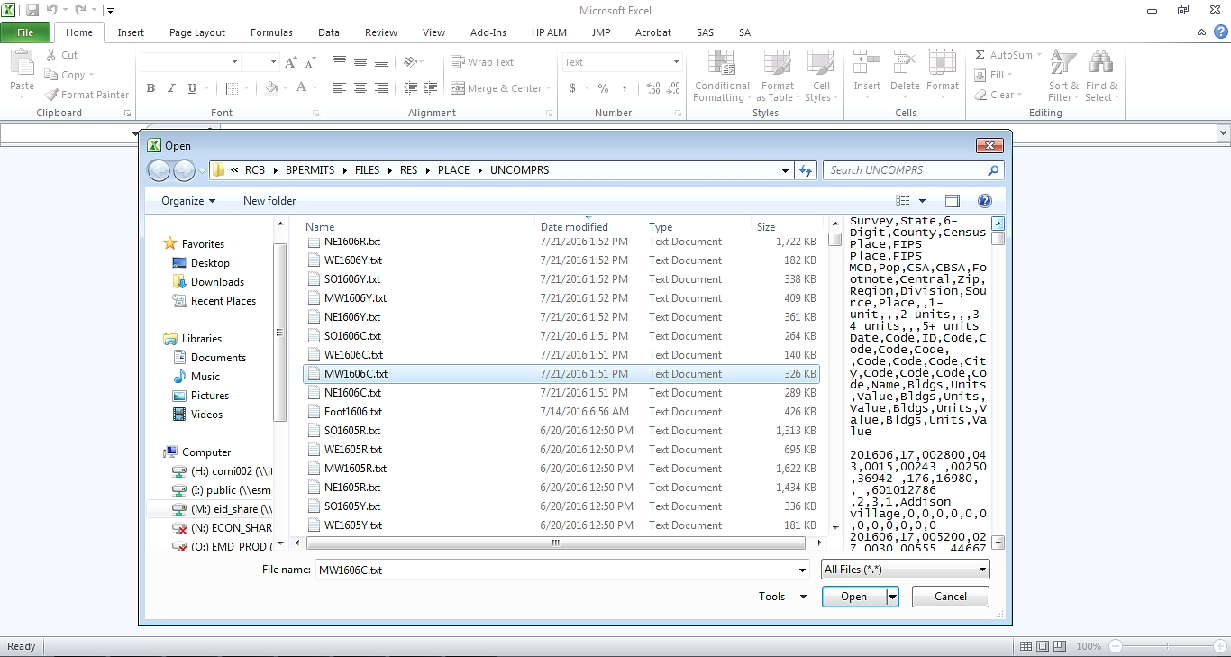

Click <Open>

On the next screen will be the Text Import Wizard

In Step 1of 3, Select ‘Delimited’ radio button

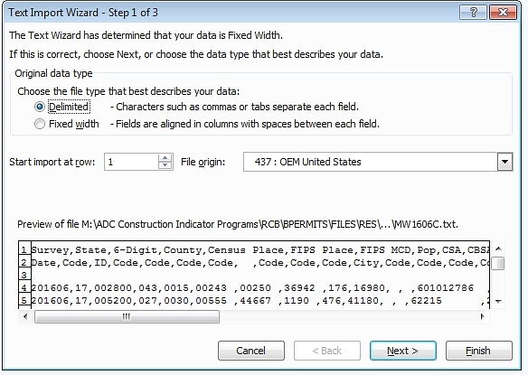

Click <Next>

In Step 2 of 3, Select ‘Comma’ as the delimiter – it’s okay to leave ‘Tab’ selected.

In the Data Preview window, you can see that the data are now in columns.

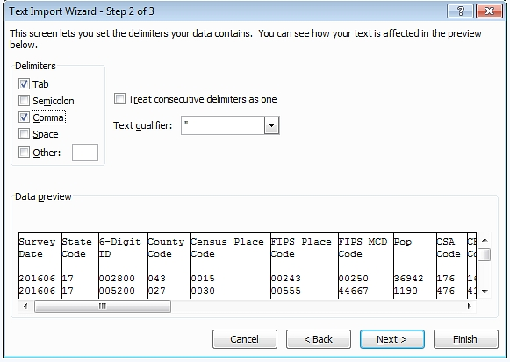

In Step 3 of 3, Select columns from ‘Survey Date’ through ‘Place Name’ and mark them as Text; leaving the other columns as General

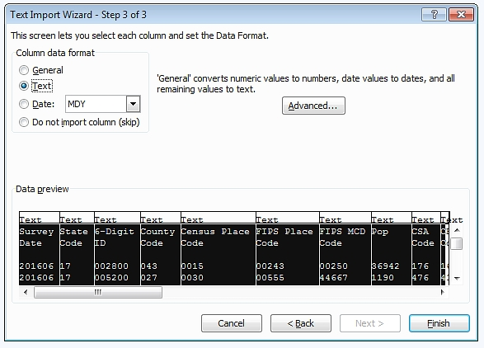

Click <Finish>

The Excel file is now created with headers and data in columns.

